ILLUMINATED DASH WINCH ROCKER SWITCH
FEATURES:
- IMPORTANT - Requires Standard ATV Winch Contactor to control Winch
- This kit includes the Rocker Switch and the 10' Wire Harness with QUICK CONNECT plug for easy wiring installation
- LED illuminated when your key is turned on to allow you to see at night
- Circuit Type (ON)-OFF-(ON)
- Double pole Switch. This mean two contact points instead of just one for better repeatability operation.
- Requires Mounting hole 0.830” x 1.450” (standard on most UTV’s)
- Max Current Rating: 20A 12VDC and 10A 24VDC
- Silver Plated Terminals

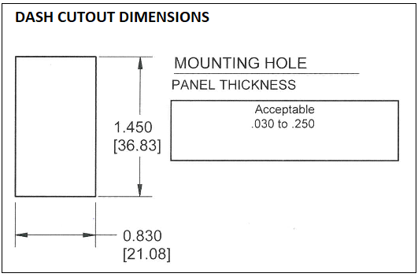
INSTALLATION:
- MOST MODERN UTV’S HAVE PREDEFINED LOCATIONS MARKED FOR MOUNTING SWITCHES LIKE THIS. IF YOUR VEHICLE HAS THIS USE A FINISHING KNIFE TO CUT OUT THE PREDEFINED AREA FOR SWITCH. IF YOUR VEHICLE DOES NOT HAVE THIS THAN FIND A SUITABLE LOCATION AND USE BELOW CUT OUT SPECIFICATIONS TO MAKE THE CUT OUT FOR THE ROCKER SWITCH.

WIRING
- Connect wires to the winch contactor. This switch includes a pre-wired plug with the harness FOR USE WITH CONTACTORS WITH FEMALE QUICK CONNECT PLUG.

